Wisconsin Fast Forward Trainee Data Bulk Upload Instructions
Welcome to Wisconsin Fast Forward - Bulk Upload Trainee Data functionality.

Project Director and Trainee Data Entry roles have the ability to prepare lists of Trainees and their data in a *.csv file (typically completed in Excel, and saved as ".csv" rather than .xlsx or .xls). Once prepared, upload the *.csv file, validate it for accuracy, fix any detected discrepancies or errors, and finally upload the Trainee Data to your Grant.

This process, while helpful for those who have to enter data for many Trainees, does require some back-and-forth work to get just right. You will need to run the WFF Application and your spreadsheet application at the same time, and you will need to switch from one program to the other. Please allow adequate time for the first few attempts at this process, follow these directions, and be patient!

To begin, enter the WFF Application. Click on MY GRANTS.
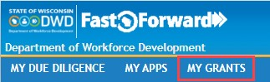

Navigate to your grant by clicking on the Correspondence ID.

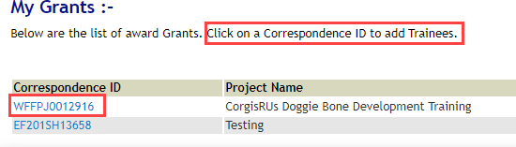

Once in your grant, navigate to the Trainees screen.
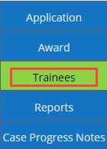

Initial View
Here is what the initial view of the Trainee Data Entry area looks like:
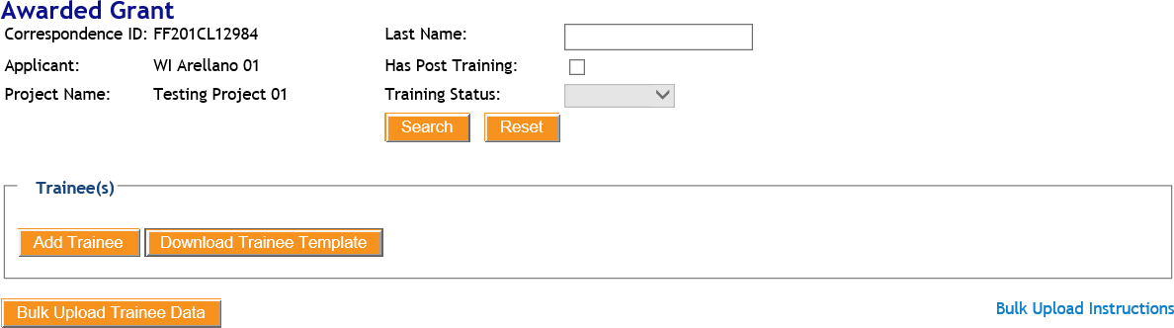

Download Trainee Template
To begin the Bulk Upload of Trainee Data, you must either run a report from your database* that matches DWD's Trainee Template, or manually enter data into DWD's Trainee Template. To manually enter data, please click the "Download Trainee Template" button.

For the purposes of these directions, we will refer to the file as Trainee_Data_<Today's Date>.csv. The date in the name of your file will be the date that you downloaded it.

*You may wish to create, or request the assistance of your own Database Administrator, Data Warehouse Administrator, or IT Support Specialist in creating, a report in your own HR data storage system that is a facsimile of the DWD Trainee Template. Note that the data structure and headers of your report must be an exact match to DWD's Trainee Template.

Depending upon which internet browser in use, you will see a variation of the following options pop up:

Click the small down-pointing arrow to the right of "Save," and select "Save as" from the dropdown menu:

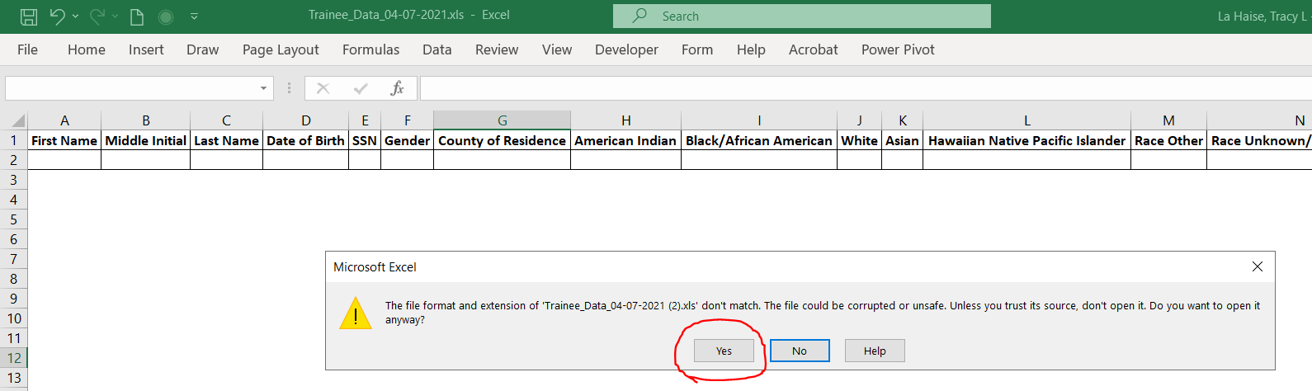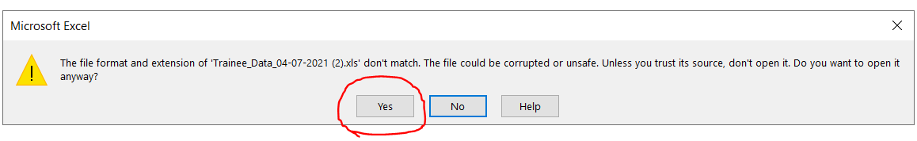Note: If you choose to Open (instead of Save) the file, you may see:

Click "Yes" to open the file.

When saving the file, you must save it as a ".csv" file, with "Save as type:" field set to "Microsoft Excel Comma Separated Values File," as explained in the directions on the next page.

You can now select the directory on your computer where you want to save the Trainee_Data_12-07-2020.csv file.
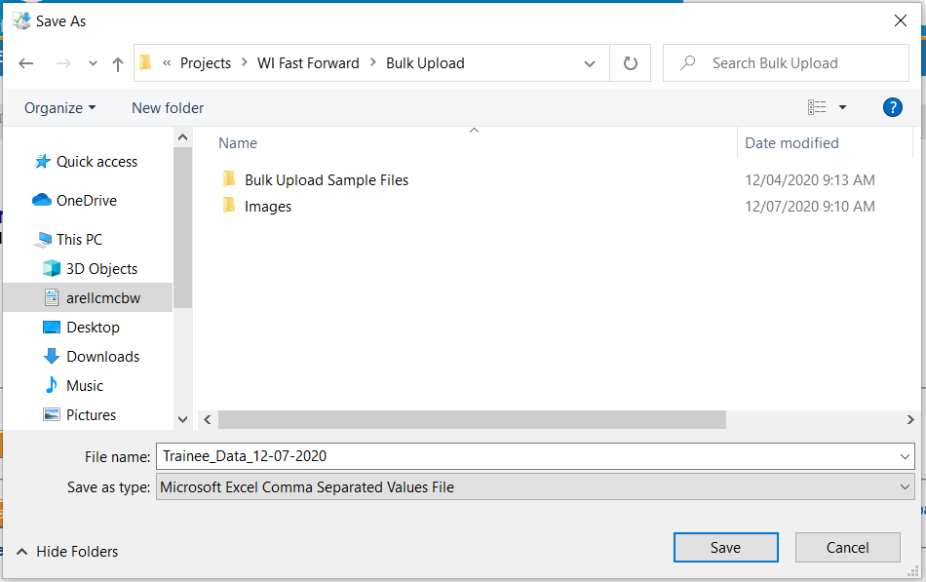

Please note that the "Save as type:" field is automatically set to "Microsoft Excel Comma Separated Values File"

This is correct.

Once download is complete, you should see a message box like this:

Now, leaving the WFF Application open, click "Open" for the Trainee Data file and the Trainee_Data_<Today's Date>.csv file will open in your spreadsheet program.

Fill-out the Trainee Data file in your spreadsheet program
If this is a new Grant Award or if you have not entered Trainee data previously, the file will not be populated with any data. It will appear as a blank "spreadsheet," with a header row and empty rows, like this:
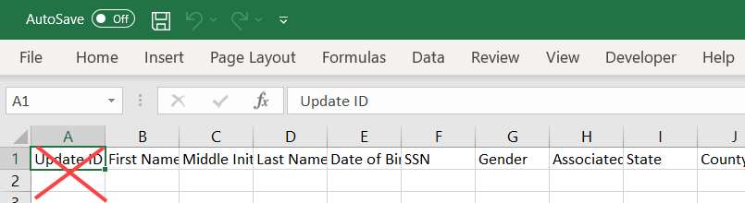

Please note: Do not enter data in the "Update ID" column. An Update ID will be assigned by the system when you upload this file.

If you already have Trainees entered into the WFF Application for your project, your Trainee Data file is populated with data for those Trainees. The spreadsheet will look like this:
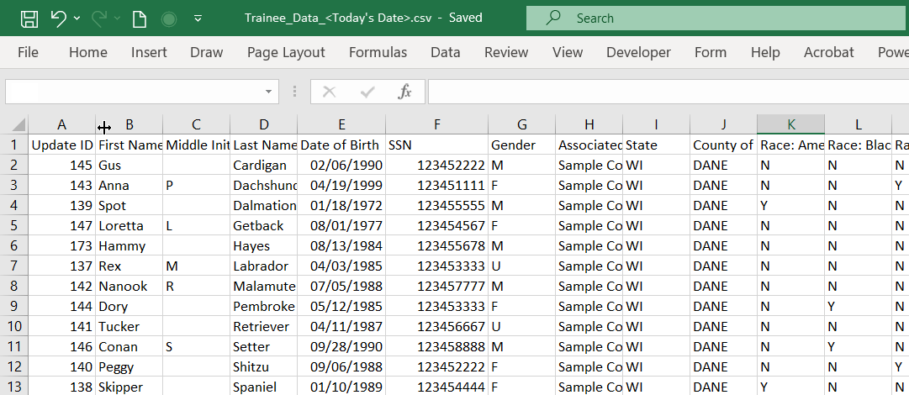
Every row is considered one Trainee. Populate every column for each Trainee for whom you have data. You may not have information for every field, and that is okay.

You may enter Pre-Training information, or both Pre- and Post-Training data. The first time you use the Bulk Upload, you may need to correct or update the Trainee Data file a few times to get everything just right.

Preparing your data file requires that you must also enter O*NET Occupation codes for the occupation of each trainee in the Trainee Data Template. To find the O*NET codes, we have provided an O*NET lookup tool in the WFF Application.

Use the O*NET Search tool to confirm or to select your O*NET Occupation Code

Leaving your spreadsheet program open, return to the WFF Application and click on the "Bulk Upload Trainee Data" button:

This expands the Trainee Bulk Upload screen as shown:

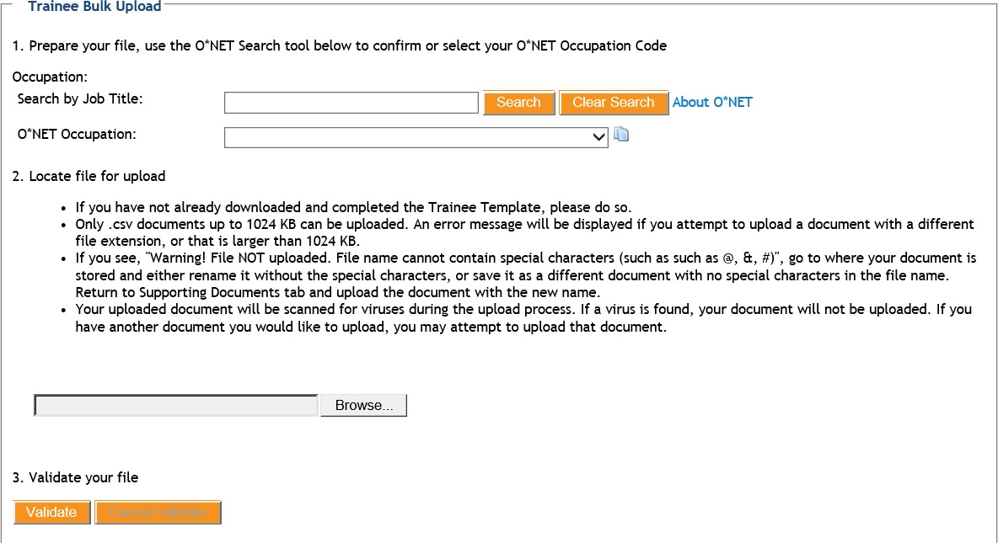

The top portion of the Trainee Bulk Upload screen consists of a search tool to find and to copy O*NET codes. You will use this tool to find the O*NET code and copy it to your clipboard. You will then switch back to your spreadsheet to enter the code. Once your spreadsheet is complete, you will save it and then return to above screen in the WFF Application to complete the upload.

If you have a Trainee that needs a Post-Training O*NET Occupation Code, use the O*NET Chooser tool (pictured as "1." in the image below). Slowly type text in the Job Title name. Click on the orange "Search" button, then click the down-pointing arrow (shown circled in green) to the right of "Select an O*NET Occupation: or search again." A dropdown list will appear with the occupations and O*NET codes for the occupation that you entered.

Once you have found the O*NET Occupation, select and copy the O*NET Code numbers only into the Post-Training O*NET Occupation Code column of the Trainee row in your Trainee Data file. Repeat this as often as needed to complete O*NET Codes for each Trainee.
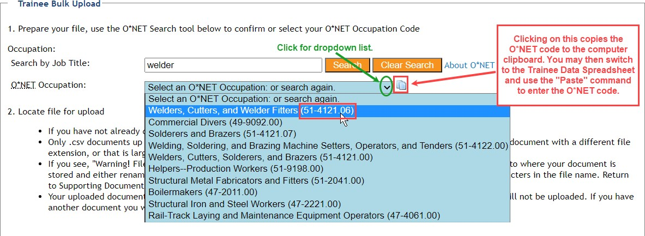

Bulk Upload Trainee Data
Once you have entered data into your Trainee Data file, including O*NET codes, use SAVE AS to save the file in ".csv" format to the location of your choice. When using Excel and saving the Trainee Data file to the Desktop, you will see:
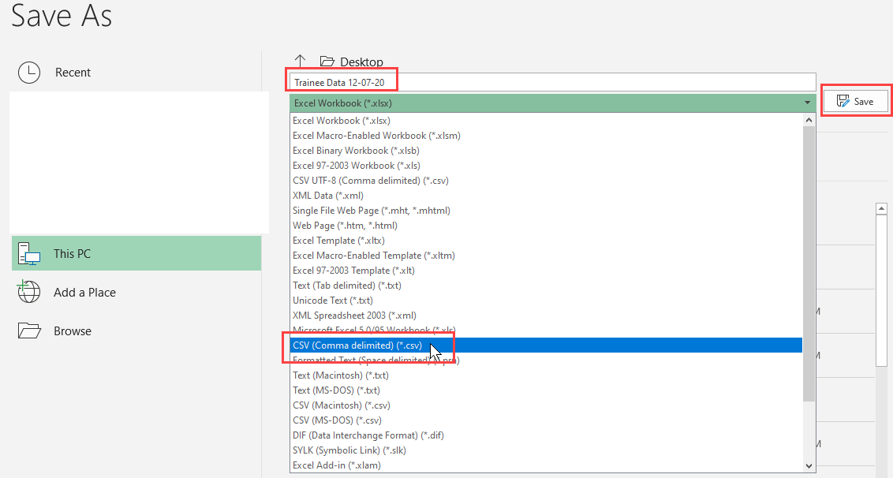

Return to the WFF Application.

Locate your file for upload

Upon adding all of your Training information for your Awarded Grant in your Trainee Data spreadsheet *.csv file, you are ready to upload it to the Wisconsin Fast Forward - Trainee Bulk Upload website. Please review the listed instructions first:
  - If you have not already downloaded and completed the Trainee Template, please do so.
  - Only .csv documents up to 1024 KB can be uploaded. An error message will be displayed if you attempt to upload a document with a different file extension, or that is larger than 1024 KB.
  - If you see, "Warning! File NOT uploaded. File name cannot contain special characters (such as such as @, &, #)", go to where your document is stored and either rename it without the special characters, or save it as a different document with no special characters in the file name. Return to Supporting Documents tab and upload the document with the new name.
  - Your uploaded document will be scanned for viruses during the upload process. If a virus is found, your document will not be uploaded. If you have another document you would like to upload, you may attempt to upload that document.
Once you have reviewed and ensured that your Trainee Data file meets these requirements, you can now click the "Browse" button and locate it:

Navigate your folder structure and locate your file. Once you have selected it, proceed to Step 3, to validate your file.

Validate your file

Prior to actually uploading the data, your spreadsheet will be checked by our system to make sure that spreadsheet contents and data formats match what we have in the WFF Application and our database. After selecting your Trainee Data file, click on the "Validate" button (under Step 3 in the Trainee Bulk Upload screen):
Any inconsistencies or errors are noted in a pop-up. You may see several Invalid Trainee(s) listed. This indicates the Trainee data rows that need attention or correction:
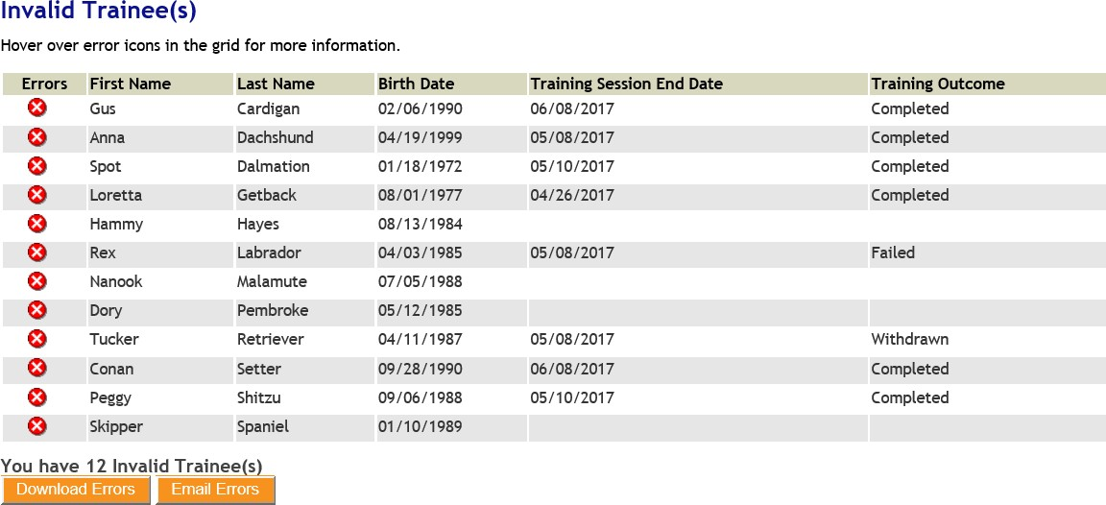

If you hold your mouse pointer over a red error circle, a pop-up will display the items that require attention:
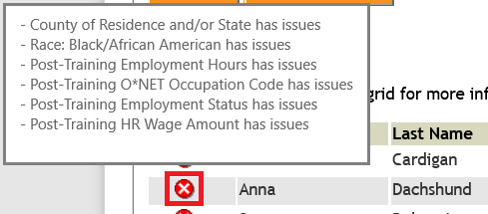

Use the Error Log as an aid to fix items in the file that have failed validation. You will see a "Download Errors" and "Email Errors" button.
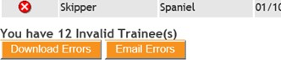
These buttons allow you to either email a copy of the Error Log file to the email address associated with your account or to download and save a new Error Log file to your computer. If you choose Download Errors, you will see:

Save this new *-Errors.csv file and begin editing the data. Note that there is now a Header Row of helpful instructions, as well as a message like "County of Residence and/or State has issues," for each item that needs attention.
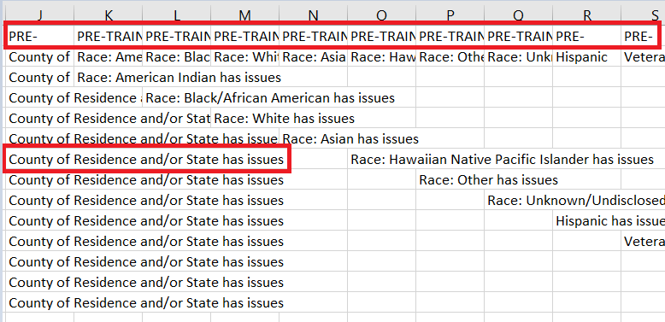

Increase the width of the spreadsheet columns, and format spreadsheet cell alignment to wrap text (Select, Right mouse click>Format Cells>Alignment>Text control = Wrap text) to enable you to see the entire text entered in a cell.

Expand the Header Row (by clicking on downward facing arrow located at the right end of Formula Bar) to see the Instructions for each column of data. Alternatively, resize the height of your first row to see the Instructions in Row 1. The Instructions will provide helpful tips for ensuring data accuracy on your Trainee Data file:
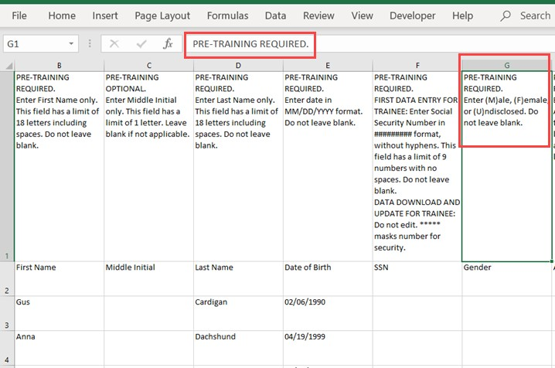

For your convenience, we have included a Data Key in these instructions.

SEE THE DATA KEY STARTING ON PAGE 13 FOR ALLOWABLE DATA AND DATA INSTRUCTIONS FOR EACH COLUMN.

Use the Error file to correct the outstanding issues in your Training Data, then retry all three steps. Your end goal is a successful validation of the data that is to be uploaded. When your file passes validation, it is ready to be uploaded:
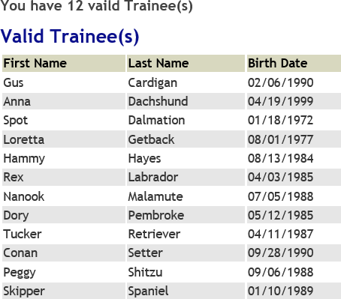

1. Upload your file

Click the "Upload" button and your Validated Trainee Data will be added to your grant.

You will now see your Trainees listed on the Trainee(s) screen in the WFF Application:
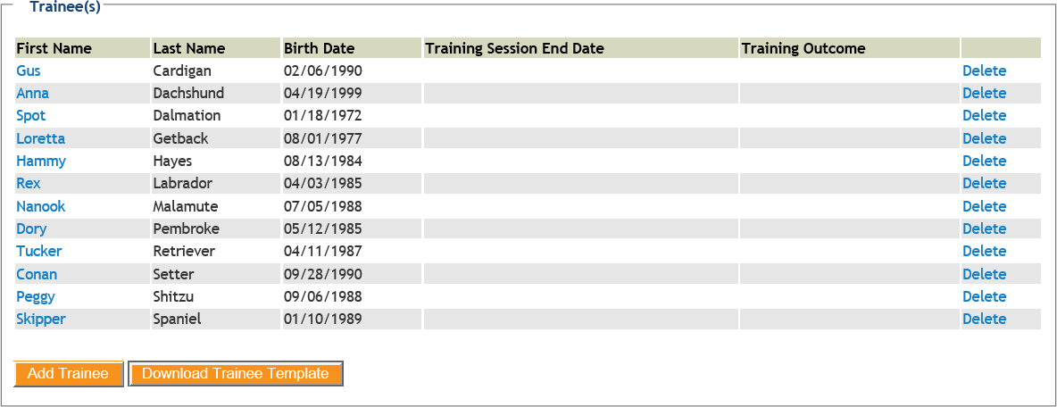

I. Final Steps
If there are issues with your Trainee Data Bulk Upload, you will receive an email:

Dear <FIRST_NAME>,

We have received your Trainee Data Bulk Upload form, #<BULK_UPLOAD_ID> at <TIME_STAMP>,
<SUBMISSION_DATE>. Unfortunately, there are some issues with your file that prevented completion of the upload.

Please review the attached Issues Log for the list of items needing attention. Please resolve or correct the items as noted. After making the requested changes, please upload your Trainee Data Bulk Upload form again.

Once uploaded successfully, your trainee data will be added to your grant project. Your grant specialist will review the data and will contact you, if needed. If you have any questions, please contact a grant specialist at WisconsinFastForward@dwd.wisconsin.gov.

Thank you!

The Wisconsin Fast Forward Team

If your Trainee Data Bulk Upload is successful, you will receive an email:

Dear <FIRST_NAME>,

We have successfully received your Bulk Upload form, #<BULK_UPLOAD_ID> at <TIME_STAMP>,
<SUBMISSION_DATE>.

Your trainee data will be added to your grant project. Your grant specialist will review the data and will contact you, if needed. If you have any questions, please contact a grant specialist at WisconsinFastForward@dwd.wisconsin.gov.

Thank you!

The Wisconsin Fast Forward Team

Follow these steps to update existing Trainees, add new Trainees, and to add or update Post-Training information. Download the latest copy of the Trainee Template using the "Download Trainee Template," update information as needed, and re-validate and re-upload once all errors have been resolved.

If you have any questions or information you would like to share about the Wisconsin Fast Forward Trainee Data Bulk Upload process, please email a Grant Specialist at WisconsinFastForward@dwd.wisconsin.gov

Data Key

Note: Yellow or red shading indicates importance or fields that are dependent on data entered in previous fields.

Column | Field Name | Allowable Data and Data Instructions
A | Update ID | DO NOT INSERT, EDIT, OR DELETE VALUES IN THIS COLUMN.  FIRST DATA ENTRY FOR TRAINEE:  If this is the first data entry for a Trainee Record, LEAVE THE VALUES IN THIS COLUMN BLANK.  EXISTING TRAINEE DATA DOWNLOAD FOR TRAINEE DATA UPDATE:  If this is a download of existing Trainee Data for an update of Trainee Data Records, DO NOT EDIT OR DELETE THE  VALUES IN THIS COLUMN.
B | First Name | PRE-TRAINING REQUIRED.  Enter First Name only. This field has a limit of 18 letters including spaces. Do not leave blank.
C | Middle Initial | PRE-TRAINING OPTIONAL.  Enter Middle Initial only. This field has a limit of 1 letter. Leave blank if not applicable.
D | Last Name | PRE-TRAINING REQUIRED.  Enter Last Name only. This field has a limit of 18 letters including spaces. Do not leave blank.
E | Date of Birth | PRE-TRAINING REQUIRED.  Enter date in MM/DD/YYYY format. Do not leave blank.
F | SSN | PRE-TRAINING REQUIRED.  FIRST DATA ENTRY FOR TRAINEE: Enter Social Security Number in ######### format, without hyphens. This field has a limit of 9 numbers with no spaces. Do not leave blank.  DATA DOWNLOAD AND UPDATE FOR TRAINEE: Do not  edit. ***** masks number for security.
G | Gender | PRE-TRAINING REQUIRED.  Enter (M)ale, (F)emale, or (U)ndisclosed. Do not leave blank.
H | Associated Partner | PRE-TRAINING REQUIRED.  Enter the name of the Associated Partner name as entered in the Project Partners information from the application. For currently employed Trainees, this is current employer name. Do not leave  blank.
I | State | PRE-TRAINING REQUIRED.  Enter the two-letter abbreviation in XX format for State of Residence. Do not leave blank.
J | County of Residence | PRE-TRAINING REQUIRED.  Enter County of Residence. Requires populated State field. Do not leave blank.

Column | Field Name | Allowable Data and Data Instructions
K | Race: American Indian | PRE-TRAINING REQUIRED.  SELECT AT LEAST ONE OPTION FROM ALL RACE DESCRIPTIONS.  Enter Y(es) to select THIS Race description. If THIS Race description is not applicable, enter N(o), and review other options.
L | Race: Black/African American | PRE-TRAINING REQUIRED.  SELECT AT LEAST ONE OPTION FROM ALL RACE DESCRIPTIONS.  Enter Y(es) to select THIS Race description. If THIS Race description is not applicable, enter N(o), and review other options.
M | Race: White | PRE-TRAINING REQUIRED.  SELECT AT LEAST ONE OPTION FROM ALL RACE DESCRIPTIONS.  Enter Y(es) to select THIS Race description. If THIS Race description is not applicable, enter N(o), and review other options.
N | Race: Asian | PRE-TRAINING REQUIRED.  SELECT AT LEAST ONE OPTION FROM ALL RACE DESCRIPTIONS.  Enter Y(es) to select THIS Race description. If THIS Race description is not applicable, enter N(o), and review other options.
O | Race: Hawaiian Native Pacific Islander | PRE-TRAINING REQUIRED.  SELECT AT LEAST ONE OPTION FROM ALL RACE DESCRIPTIONS.  Enter Y(es) to select THIS Race description. If THIS Race description is not applicable, enter N(o), and review other options.
P | Race: Other | PRE-TRAINING REQUIRED.  SELECT AT LEAST ONE OPTION FROM ALL RACE DESCRIPTIONS.  Enter Y(es) to select THIS Race description. If THIS Race description is not applicable, enter N(o), and review other options.
Q | Race: Unknown/Undisclosed | PRE-TRAINING REQUIRED.  SELECT AT LEAST ONE OPTION FROM ALL RACE DESCRIPTIONS.  Enter Y(es) to select THIS Race description. If THIS Race description is not applicable, enter N(o), and review other options.
R | Hispanic | PRE-TRAINING REQUIRED.  Enter Y(es), N(o), or U(ndisclosed) to describe Hispanic ethnicity. Do not leave blank.
S | Veteran Status | PRE-TRAINING REQUIRED.  Enter Y(es), N(o), or U(ndisclosed) to select Veteran Status. Do not leave blank.
T | Disability Status | PRE-TRAINING REQUIRED.  Enter Y(es), N(o), or U(ndisclosed) to select Disability Status. Do not leave blank.
U | Ex-Offender | PRE-TRAINING REQUIRED.  Enter Y(es), N(o), or U(ndisclosed) to select Ex-Offender Status. Do not leave blank.

Column | Field Name | Allowable Data and Data Instructions
V | First Time Graduates | PRE-TRAINING REQUIRED.  Enter Y(es), N(o), or U(ndisclosed) to indicate that the Trainee  graduated from secondary school with the past two years. Do not leave blank.
W | Training Start Date | PRE-TRAINING REQUIRED.  Enter date in MM/DD/YYYY format. Do not leave blank.
X | Trainee Classification | PRE-TRAINING REQUIRED.  Enter the numeric code for Employment Classification. Do not leave blank.  - Unemployed  - Underemployed  - Incumbent - Existing
Y | Pre-Training Employment Status | PRE-TRAINING REQUIRED.  Enter the numeric code for Employment Status. Do not leave blank. 1 Employed  2 Unemployed
Z | Pre-Training Employment Hours | PRE-TRAINING REQUIRED IF PRE-TRAINING EMPLOYMENT STATUS = EMPLOYED.  Enter the numeric code for Pre-Training Employment Hours. Do not leave blank.  1 Full-Time 32 or more hours per week 2 Part-time
AA | Pre-Training Employment Type | PRE-TRAINING REQUIRED IF PRE-TRAINING EMPLOYMENT STATUS = EMPLOYED.  Enter the numeric code for Pre-Training Employment Type. Do not leave blank.  - Temporary  - Seasonal  - Permanent
AB | Pre-Training Employer Name | PRE-TRAINING REQUIRED IF PRE-TRAINING EMPLOYMENT STATUS = EMPLOYED.  Enter Pre-Training Employer Name from the Project Partners listed in the application, or enter "Other." This field has a limit of 50 letters including spaces. Do not leave blank.
AC | Pre-Training Employer Name if 'Other' | PRE-TRAINING REQUIRED IF PRE-TRAINING EMPLOYMENT STATUS = EMPLOYED.  If "Other" entered for Pre-Training Employer Name, enter Pre- Training Employer Name. This field has a limit of 50 letters including spaces. Do not leave blank.
AD | Pre-Training Hourly Wage | PRE-TRAINING REQUIRED IF PRE-TRAINING EMPLOYMENT STATUS = EMPLOYED.  Enter Pre-Training Hourly Wage in $XXX.XX format. This field has a limit of 8 numbers before the decimal and 2 numbers after.  Do not leave blank.

Column | Field Name | Allowable Data and Data Instructions
AE | Post-Training Course Title(s) | POST-TRAINING REQUIRED.  Enter the name of Course Title from the courses listed in the application, or enter "Other." This field has a limit of 50 letters and spaces. Do not leave blank.
AF | Post-Training Course Title(s) if Other | POST-TRAINING REQUIRED.  If "Other" entered for Post-Training Course Title(s), enter the name of Course Title. This field has a limit of 50 letters and spaces. Do not leave blank.
AG | Post-Training Training Session End Date | POST-TRAINING REQUIRED.  Enter date in MM/DD/YYYY format. Do not leave blank.
AH | Post-Training Training Outcome | POST-TRAINING REQUIRED.  Enter the numeric code for Course Outcome. Do not leave blank. 1 Completed  - Failed  - Withdrawn
AI | Post-Training Failed/Withdrawn Comment | POST-TRAINING REQUIRED IF POST-TRAINING TRAINING OUTCOME = FAILED OR WITHDRAWN.  Explain the reason(s) for failure or withdrawal. This field has a limit of 500 characters including spaces. Do not leave blank.
AJ | Post-Training Outcome Certification: Industry Recognized Certificate | POST-TRAINING REQUIRED IF POST-TRAINING TRAINING OUTCOME = COMPLETED.  Enter Y(es) or N(o) if an Industry Recognized Certificate was earned. Do not leave blank.
AK | Post-Training Outcome Certification: Course Credits | POST-TRAINING REQUIRED IF POST-TRAINING TRAINING OUTCOME = COMPLETED.  Enter Y(es) or N(o) if Course Credits were earned. Do not leave blank.
AL | Post-Training Outcome Certification: Continuing Education Units | POST-TRAINING REQUIRED IF POST-TRAINING TRAINING OUTCOME = COMPLETED.  Enter Y(es) or N(o) if Continuing Education Units were earned. Do not leave blank.
AM | Post-Training Outcome Certification: Accreditation Received | POST-TRAINING REQUIRED IF POST-TRAINING TRAINING OUTCOME = COMPLETED.  Enter Y(es) or N(o) if Accreditation was earned. Do not leave blank.
AN | Post-Training Program Outcome | POST-TRAINING REQUIRED IF POST-TRAINING TRAINING OUTCOME = COMPLETED.  Enter the numeric code for Post-Training Program Outcome. Do not leave blank.  - Employed  - Not Employed  - Unknown

Column | Field Name | Allowable Data and Data Instructions
AO | Post-Training Employment Type | POST-TRAINING REQUIRED IF POST-TRAINING TRAINING OUTCOME = COMPLETED.  Enter the numeric code for Post-Training Employment Type. Do not leave blank.  - Temporary  - Seasonal  - Permanent
AP | Post-Training Employment Hours | POST-TRAINING REQUIRED IF POST-TRAINING TRAINING OUTCOME = COMPLETED.  Enter the numeric code for Post-Training Employment Hours. Do not leave blank.  1 Full-Time 32 or more hours per week 2 Part-time
AQ | Post-Training O*NET Occupation | POST-TRAINING REQUIRED IF POST-TRAINING TRAINING  OUTCOME = COMPLETED. Enter Post-Training O*NET Occupation Code in ##-####.## format. Do not leave blank.
AR | Post-Training O*NET Occupation Code if Other | POST-TRAINING REQUIRED IF POST-TRAINING TRAINING  OUTCOME = COMPLETED. Enter Post-Training O*NET Occupation name. Do not leave blank.
AS | Post-Training Employer Name | POST-TRAINING REQUIRED IF POST-TRAINING TRAINING  OUTCOME = COMPLETED. Enter Post-Training Employer Name from the Project Partners listed in the application, or enter "Other." This field has a limit of 50 letters including spaces. Do not leave  blank.
AT | Post-Training Employer Name if 'Other' | POST-TRAINING REQUIRED IF POST-TRAINING TRAINING  OUTCOME = COMPLETED. If "Other" entered for Post-Training Employer Name, enter Post-Training Employer Name. This field has a limit of 50 letters including spaces. Do not leave blank.
AU | Post-Training HR Wage Amount | POST-TRAINING REQUIRED IF POST-TRAINING TRAINING  OUTCOME = COMPLETED. Enter Post-Training Hourly Wage in  $XXX.XX format. This field has a limit of 8 numbers before the decimal and 2 numbers after. Do not leave blank.

